**Azure fundamental assignment 1**

1. **What is cloud computing? What is Azure?**

Cloud computing is a general term for **anything that involves delivering hosted services over the internet**. These services are divided into three main categories or types of cloud computing: infrastructure as a service (IaaS), platform as a service (PaaS) and **software** as a service (SaaS).

Azure is **a public cloud computing platform**—with solutions including Infrastructure as a Service (IaaS), Platform as a Service (PaaS), and Software as a Service (SaaS) that can be used for services such as analytics, virtual computing, storage, networking, and much more.

1. **How to create an Azure account list the steps and requirements?**

**Creating the Free Azure account**

1. Go to <https://azure.microsoft.com/free>.
2. Click on “Start for free” button.
3. You will be redirected to a sign-in form. You need the Microsoft account. If you don’t have any, created one or there is also the possibility to use [GitHub](https://github.com/)account since Microsoft bought it.
4. After your successful authorization you will be redirected to Identity verification by card form.
5. Now that only remains is checking the agreement, click sign up and your Azure account is created.

**Requirements**:

* + - 1. Microsoft / Github account
      2. Phone with valid sim for verification
      3. Debit/Credit card

1. **Describe different types of cloud models.**

## There are 3 main types of Cloud models

## 

1. **Public cloud**

Public clouds are managed by third parties which provide cloud services over the internet to the public, these services are available as pay-as-you-go billing models.   
They offer solutions for minimizing IT infrastructure costs and become a good option for handling peak loads on the local infrastructure. Public clouds are the go-to option for small enterprises, which are able to start their businesses without large upfront investments by completely relying on public infrastructure for their IT needs.   
The fundamental characteristics of public clouds are **multitenancy**. A public cloud is meant to serve multiple users, not a single customer. A user requires a virtual computing environment that is separated, and most likely isolated, from other users.

1. **Private cloud**

Private clouds are distributed systems that work on private infrastructure and provide the users with dynamic provisioning of computing resources. Instead of a pay-as-you-go model in private clouds, there could be other schemes that manage the usage of the cloud and proportionally billing of the different departments or sections of an enterprise.

1. **Hybrid cloud**

A hybrid cloud is a heterogeneous distributed system formed by combining facilities of public cloud and private cloud. For this reason, they are also called **heterogeneous clouds.**   
A major drawback of private deployments is the inability to scale on-demand and efficiently address peak loads. Here public clouds are needed. Hence, a hybrid cloud takes advantage of both public and private clouds.

1. **Describe different cloud services.**

Cloud computing is offered in three different service models which each satisfy a unique set of business requirements. These three models are known as **Software as a Service (SaaS), Platform as a Service (PaaS), and Infrastructure as a Service (IaaS)**.

**Infrastructure as a Service (IaaS)**

Use only infrastructure from cloud provider

Example: Using VM to deploy your applications or databases

You are responsible for:

Application Code and Runtime Configuring load balancing Auto scaling OS upgrades and patches Availability etc..

**Platform as a Service (PaaS)**

Use a platform provided by cloud

Cloud provider is responsible for:

OS (incl. upgrades and patches)

Application Runtime

Auto scaling, Availability & Load balancing etc..

You are responsible for:

Configuration (of Application and Services)

Application code (if needed)

Examples: Azure App Service Databases - Relational & NoSQL (Amazon RDS, Google Cloud SQL, Azure SQL Database etc) Queues, AI, ML, Operations etc

**Software as a service (SaaS)**

Allows users to connect to and use cloud-based apps over the Internet. Common examples are email, calendaring and office tools (such as Microsoft Office 365).

SaaS provides a complete software solution which you purchase on a pay-as-you-go basis from a [cloud service provider](https://azure.microsoft.com/en-in/overview/choosing-a-cloud-service-provider/). You rent the use of an app for your organisation and your users connect to it over the Internet, usually with a web browser. All of the underlying infrastructure, middleware, app software and app data are located in the service provider’s data center. The service provider manages the hardware and software and with the appropriate service agreement, will ensure the availability and the security of the app and your data as well. SaaS allows your organisation to get quickly up and running with an app at minimal upfront cost.

1. **What are some cloud computing advantages?**

Trade "capital expense" for "variable expense"

Benefit from massive economies of scale

Stop guessing capacity

Stop spending money running and maintaining data centers

"Go global" in minutes for application deployment and launch from one env to other.

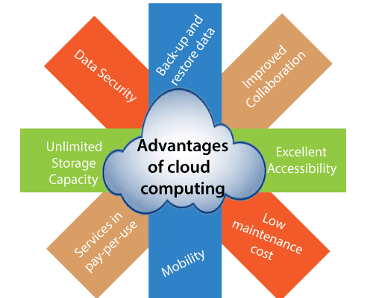

1. **Differentiate Capital expenses vs. operating expenses**

|  | Capital Expenditure | Operational Expenditure |
| --- | --- | --- |
| Up front cost | Significant | None |
| Ongoing cost | Low | Based on usage |
| Tax Deduction | Over time | Same year |
| Early Termination | No | Anytime |
| Maintenance | Significant | Low |
| Value over time | Lowers | No change |